(Created by Ash Maurya. It was adapted from the Business Model Canvas created by Alexander Osterwalder in 2010 for use with larger, mature businesses. The Lean Canvas is intended for small, entrepreneurial businesses, with its main objective to make it as actionable as possible while staying entrepreneur-focused. Think of it as a grounds-up tactical plan the entrepreneur can navigate from ideation to successful startup.
- Define your user
Before you get started the main question is: Do you have a problem worth solving? If so the first step is to brainstorm who could be your customer or user: define 2-3 specific and small customer groups. Customers are those who pay for your products. In comparison to the business model canvas, the Lean Canvas is designed to focus on one customer group. Therefor create a separate Lean Canvas for every customer group.
- Create Solutions
Based on the identified problems, ideate and define a solution to every problem: list the three most important features for a solution.
- Define your Unique Value Proposition
The Unique Value Proposition is a clear message that describes the advantages of your offer, what makes you different and distinguishes you from the competition.
- Think about the Channels
What are the channels you want to use to reach your customer? Define inbound channels that lead customers to your offer like SEO, white papers, blogs, social media – and outbound channels like ads, calls, fairs and conventions. BE CREATIVE!
- Pricing
- Define the revenue streams and the prices for your offer. The pricing is part of your offer and needs to be designed and tested.
- Key Metrics
To understand if your idea and your business work well define key metrics as indicators to measure your success. For the beginning, key metrics are the activities of a user that help the business grow (e.g. number of registrations, number of prospects, etc.)
- Costs
List the most important costs for your offer. This might influence the pricing.
- Unfair Advantage
As a last step, define your Unfair Advantage: what makes you unique that is not easily copied? E.g. reputation, unique brand experience, unique partnerships that lead to an offer that cannot be copied.

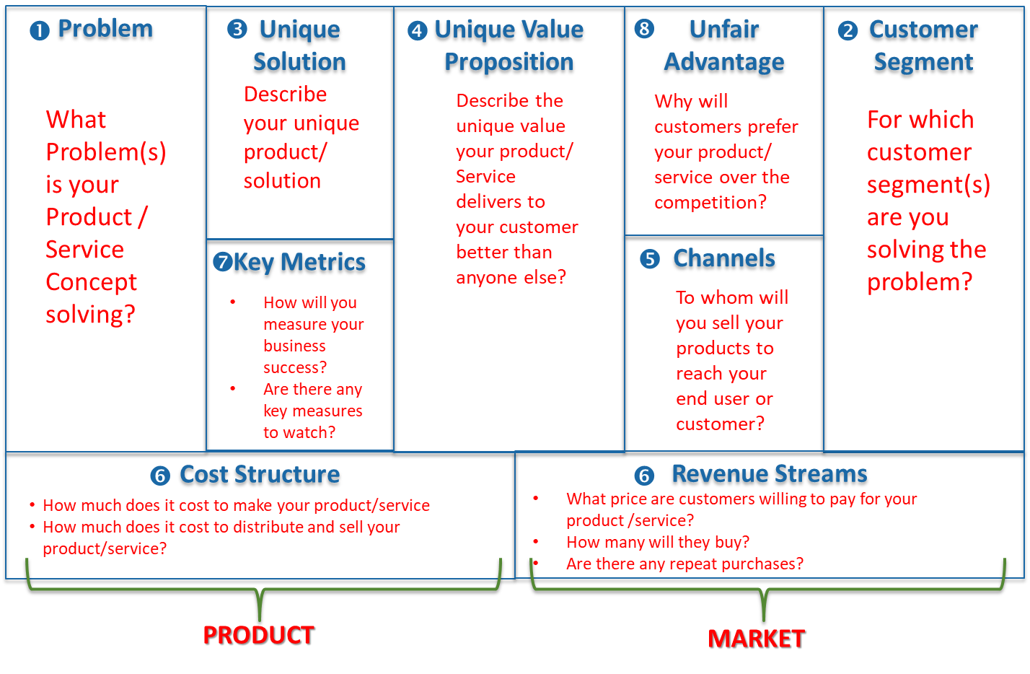
Problem
Customer Segment

Unique Solution
Unfair Advantage
Key Metrics
Channels
Cost Structure
Revenue Streams
Unique Value Proposition

